Lab Assignment 1.2 – AI Assisted Coding
Santhosh kumar Katakam
2403A51L21
B:51

Task 0: GitHub Copilot Installation & Configuration
Steps Followed:
- Installed Visual Studio Code
- Opened Extensions Marketplace
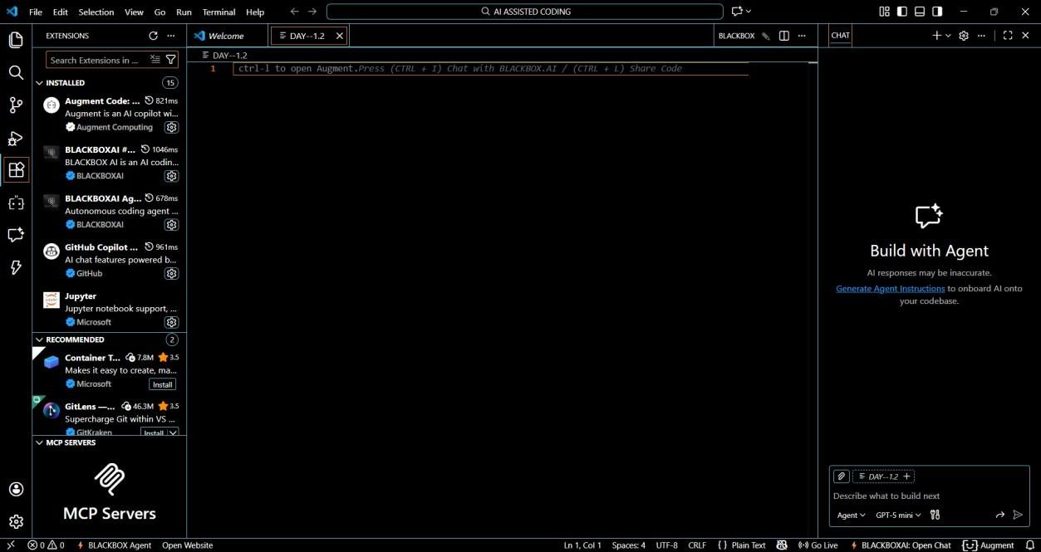
- Searched for GitHub Copilot
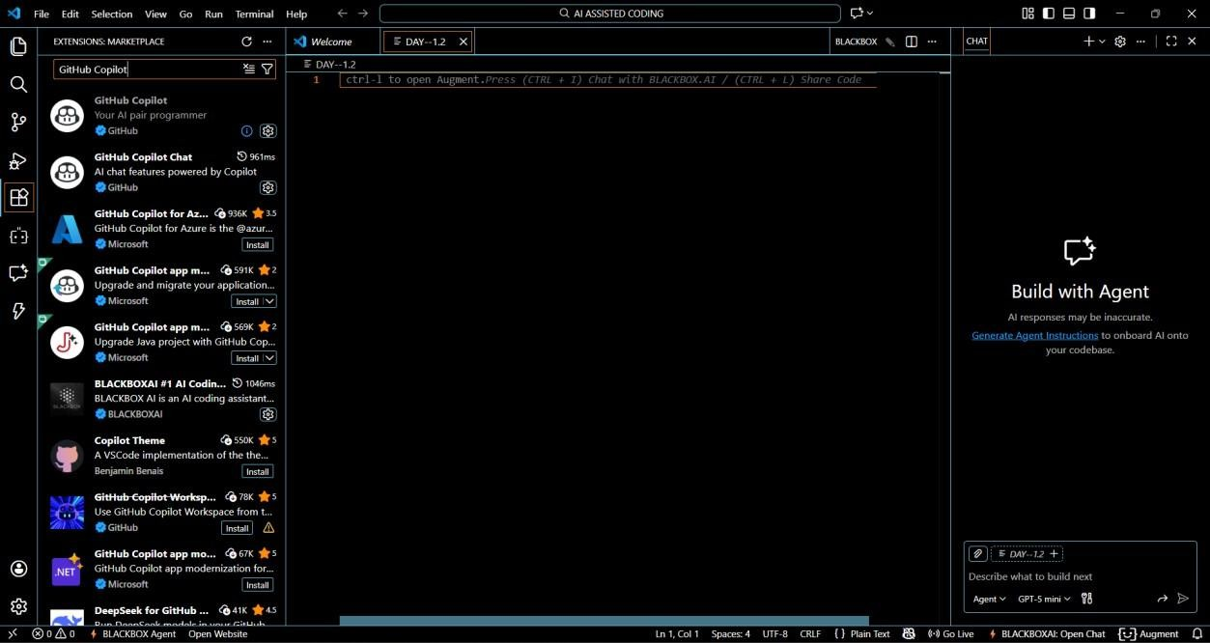
- Clicked Install
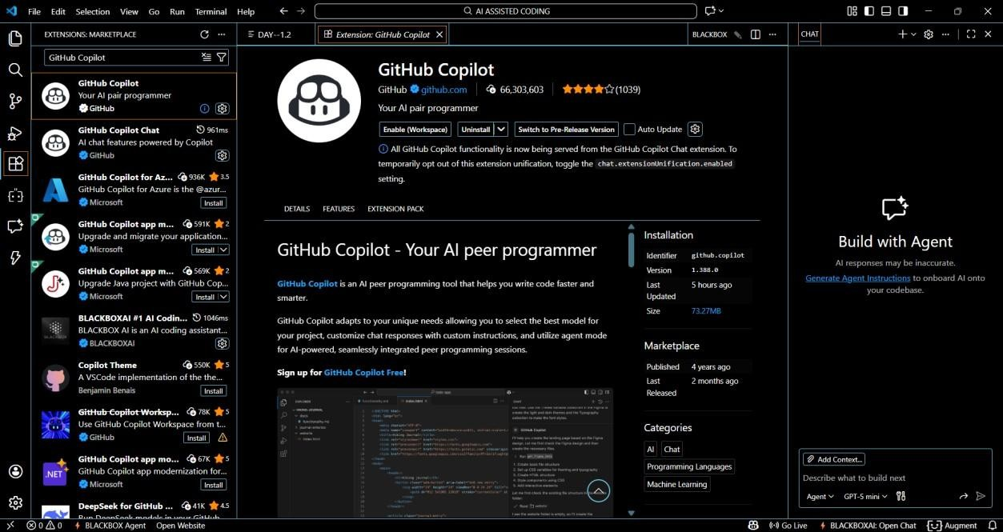
- Signed in with GitHub Account
- Enabled Copilot suggestions
- Verified Copilot inline suggestions in Python file
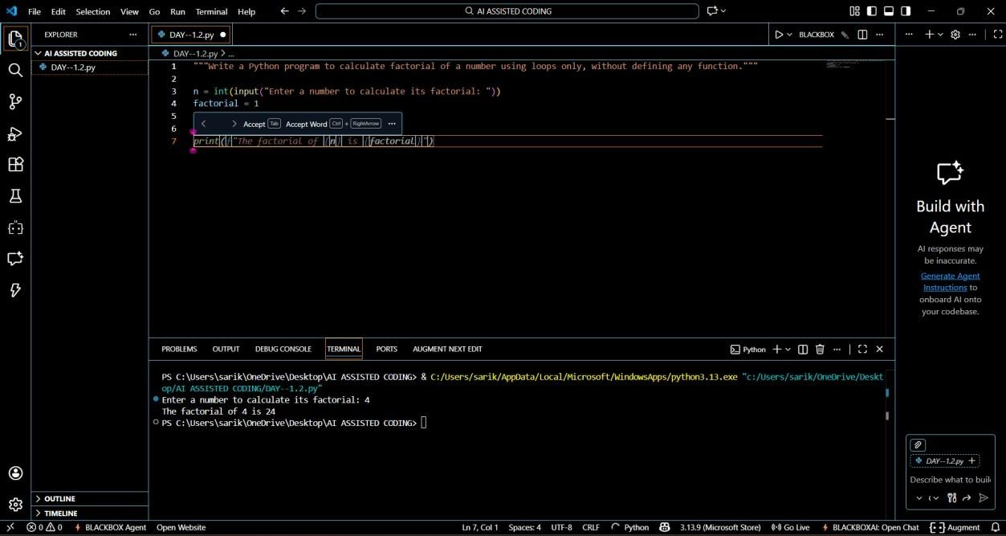

Task 1: AI-Generated Logic Without Modularization (Factorial without Functions)
Prompt Used: “Write a Python program to calculate factorial of a number using loops only, without defining any function.”
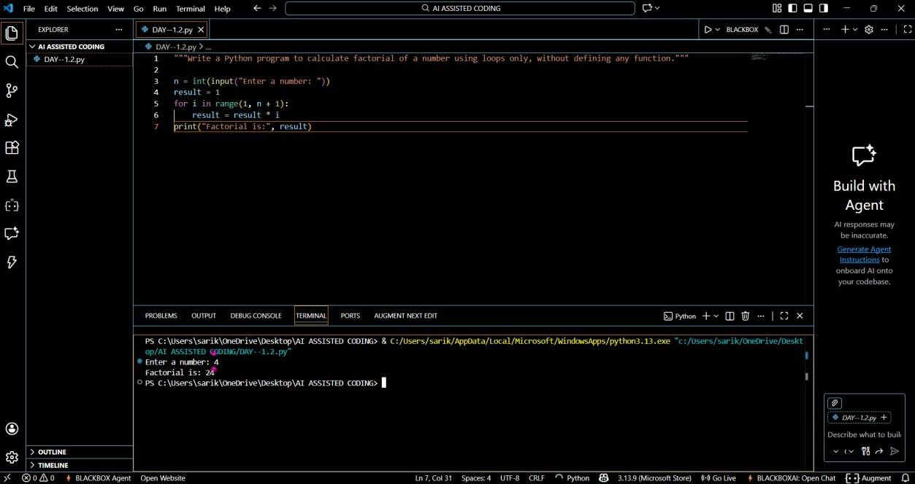
GitHub Copilot was very helpful for a beginner as it generated correct logic instantly.
It followed basic Python syntax and loop structure accurately.
The code was readable and easy to understand.
However, it did not include input validation automatically.
Best practices like modular design were not applied unless explicitly prompted.

Task 2: AI Code Optimization & Cleanup Original Code:

Prompt Used: “Optimize this code and make it more readable”
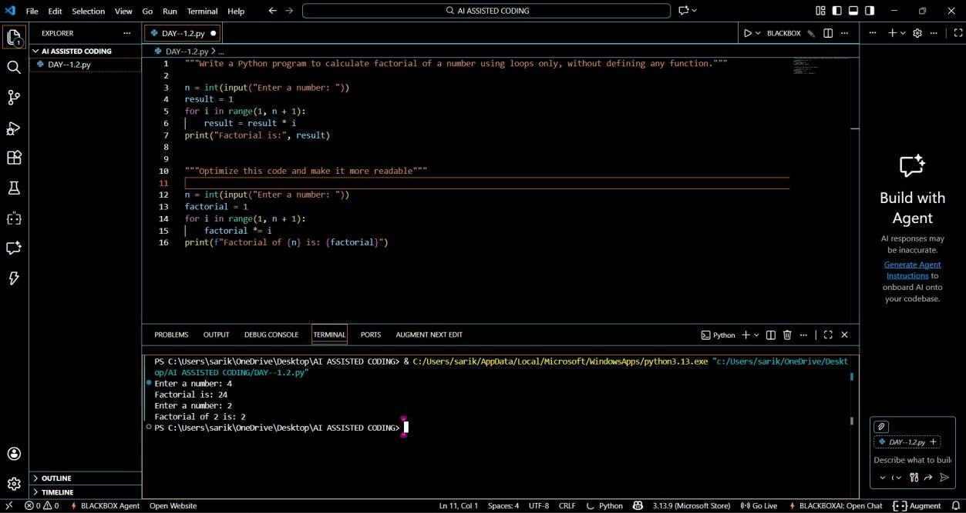
The optimized version improves clarity, maintainability, and readability without affecting performance.

Task 3: Modular Design Using AI Assistance (Factorial with Functions)
Prompt Used: “Create a Python function to calculate factorial and call it from main block”
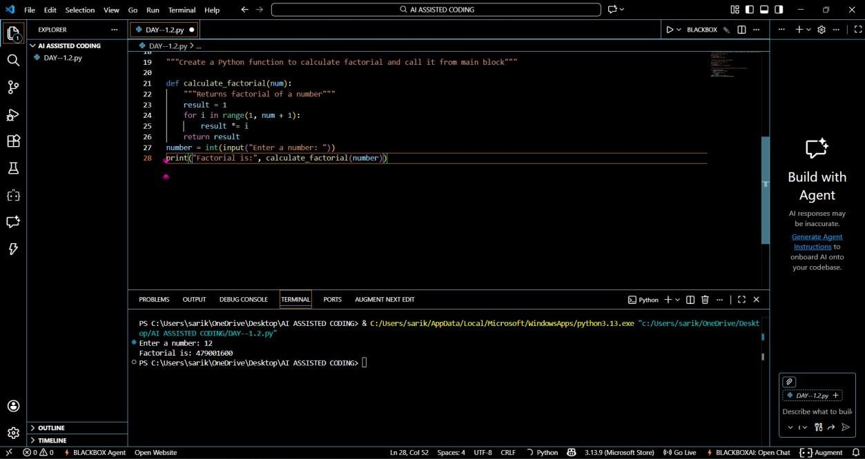
Modularity improves reusability by allowing the same function to be used across multiple programs. It also simplifies testing and debugging.

Task 4: Comparative Analysis
Procedural vs Modular AI Code
Without
Criteria | _{Function} With Function
Logic Clarity | Moderate High
Reusability | No Yes
Debugging Ease | Difficult Easy
Large Project Suitability | Poor Excellent
AI Dependency Risk | Higher Lower
Conclusion:
Function-based design is more scalable and suitable for real-world applications.

Task 5: Iterative vs Recursive AI Code
Prompt Used: “Generate iterative and recursive factorial programs in
Python”
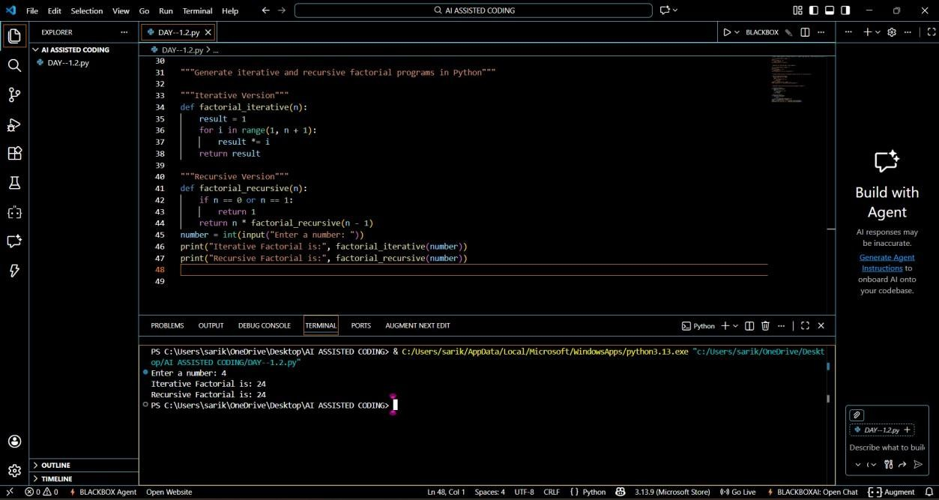
Execution Flow Explanation:
- Iterative version uses a loop and constant memory.
- Recursive version uses function calls and stack memory.
Comparison:
Aspect | Iterative | Recursive
Readability | Simple | Elegant
Stack Usage | No | Yes
Performance | Faster | Slower
Risk | Low | Stack Overflow
Recommendation | Preferred | Avoid for large inputs

